ADST11SD300&310
Fingerprint Identification Module
User’s Guide

(Ver 4.0)

ID System Technology Co.,Ltd
http://www.szadst.com

Tel:86-755-33160920
Fax:86-755-86039586
List
1. Summary 3
1.1 Main functions 3
1.2 Application examples 3
1.3 Technology Parameter 4
1.4 Default Setting 4
2. Configration and Connector 5
2.1 Mount and Connector 5
2.2 Dimension of ADST11SD300 6
2.3 Dimension of ADST11SD310 7
3. Communication Protocol 7
3.1 The process of communication 7
3.2 Classify of communication packet 8
3.2.1 Command packet 8
3.2.2 Response packet 8
3.2.3 Data Packet 8
3.3 Packet Structure 9
3.3.1 Packet Identify Code 9
3.3.2 Structure of Command Packet 9
3.3.3 Response packet 9
3.3.4 Command Data Packet 10
3.3.5 Response Data Packet 10
4. Packet Command Detail Description 11
4.1 Structure of Fingerprint Template Data is follow 11
4.2 Command List 11
5. Appendix 14
5.1 Response and Error Code 14
5.2 Flow of Enroll and Verify and Identify process 15
5.2.1 Enroll 15
5.2.2 Verify & Identify 16

1. Summary
Functions and Characteristic:
ADST11SD3xx serial is All-in-one (Optic sensor +CMOS image sensor + CPU +Flash memory) embedded stand-alone fingerprint identification module, it is convenient for second development,Extremely easy to integrate minimizing time-to-market.
1.1 Main functions
Optic sensor is reliable and Low-cost, High ESD Protection
1:N Identification (One-to-Many)
1:1 Verification (One-to-One)
High speed fingerprint identification algorithm engine
Self study function
Fingerprint template data read from /write to FLASH memory function
Get Feature Data of Captured fingerprint
Verify Downloaded Feature with Captured fingerprint
Identify Downloaded Feature with Captured fingerprint
Security Level setting
Standby mode
Communication interface :UART
1.2 Application examples
- Access control systems
- Time & Attendance
- Locks, safes
- POS terminals

1.3 Technology Parameter
Item | Description
CPU | Core:ARC (120Mhz,1M bit Flash Memory,128K SRAM)
Sensor | Optic sensor
Fingerprint capacity | 500~5000 can be enlarge，Default setting is 3000 fingerprints
FAR | < 0.001 %（Security Level is 3）
FRR | < 0.1 %（Security Level is 3）
Match Mode | 1:N identification and 1:1 verification
Fingerprint Data size | 496 Byte
Security level | Level 1 to Level 5 can be set , default setting is : Level 3
Time of Response | Fingerprint pretreatment < 0.45
Time of Response | 1:N matching（3000 fingerprints）< 1s
Resistant to Abrasion | >1 Million Finger Press
Communication | UART：Parity = NONE,Stop Bit = 1,Flow Control = NONE  Baud rate is 9600/19200/38400/57600/115200 (BPS)  Default setting：115200bps
Working Voltage | DC 3.3V-5V
Working Current | Max 100mA，Standby Mode less than 5mA
Working Environment | Working Temperature：-10℃ to 60℃  Relative humidity：20%– 80%
Storage Environment | Storage temperature: -20℃ to 80℃  Storage humidity:<90%
1.4 Default Setting
Item | Value
Security Level（1～5） | 3
Finger Time Out（0～60S） | 5s
BaudRate（9600，19200，38400，57600，115200）BPS | 115200 BPS
Fingerprint Duplication Check（ON/OFF） | ON

2. Configration and Connector
2.1 Mount and Connector
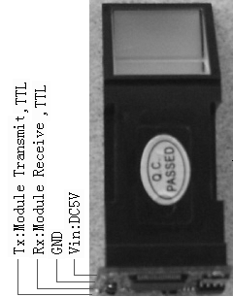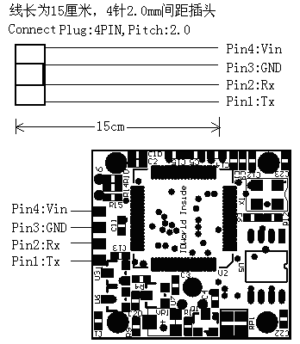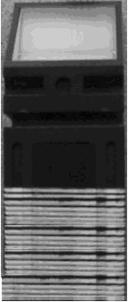
Fig2-1. Shape of ADST11SD300&310

Table2-1. Connector Signal description
Pin No. | Color | Signal name | Signal Description
PIN 1 | White | UART-TX | Module Transmit Output,3.3V TTL Logic
PIN 2 | Yellow | UART-RX | Module Receive Input,3.3V TTL Logic
PIN 3 | Black | GND | GND
PIN 4 | Red | VIN | DC Input,Range of voltage is 3.3V

2.2 Dimension of ADST11SD300
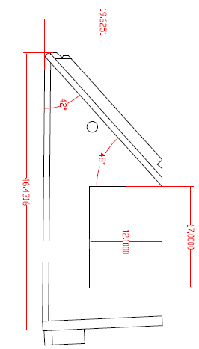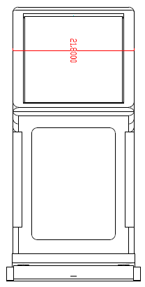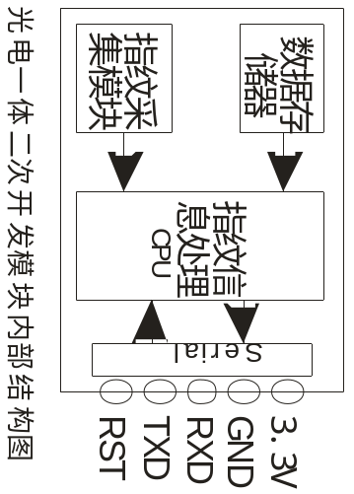

Fig2-2. Dimension of ADST11SD300
2.3 Dimension of ADST11SD310
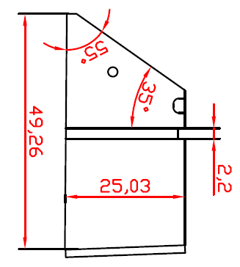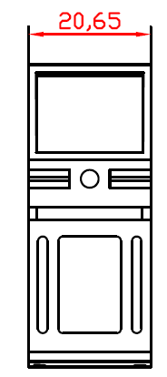

Fig 2-3. Dimension of ADST11SD310

3. Communication Protocol
The module is used as a slave device. The Master device sends relative commands to control it.
The CMD sent by the master and the ACK signal returned by the module.
Command interface: UART (Universal Asynchronous Receiver Transmitter)
Default Setting is : 115200BPS ,1 start-bit ,1 stop-bit ,no check bit
3.1 The process of communication
H O S T T A R G E T（ADST11SD300&310）

Begin
Wait Command

Command Packet
Send Command
Receive Command
Data Packet

Process Command

Response Packet
Receive Result
Send Result
Data Packet

End

Fig3-1.Process of Communication
Notice. Host do not send next command until receive result , except send FP Cancel
3.2 Classify of communication packet
3.2.1 Command packet
Command Packet is the instruction from Host to Target (ADST11SD3xx),
Total length of the command packet is 24 Bytes
3.2.2 Response packet
Response packet is result of execute command packet, from Target (ADST11SD3xx) to Host,
Total length of the command packet is 24 Bytes
3.2.3 Data Packet
When length of Command Parameter or Data is larger than 16 Bytes, Utilize Data Packet
to transmit block Data, the maximum length of Data Packet is 512Bytes
3.3 Packet Structure
3.3.1 Packet Identify Code
Section of start 2byte prefix define type of packet
Type of Packet | Code
Command packet | 0xAA55
Response packet | 0x55AA
Command Data Packet | 0xA55A
Response Data Packet | 0x5AA5

3.3.2 Structure of Command Packet
PREFIX |  | CMD |  | LEN |  | DATA |  |  |  | CKS
0x55 | 0xAA | L | H | L | H | D0 | D1 | … | D15 | L | H
0 | 1 | 2 | 3 | 4 | 5 | 6 | 7 | … | 21 | 22 | 23

OFFSET | FIELD | TYPE | SIZE | DESCRYPTION
0 | PREFIX | WORD | 2byte | Packet Identify code
2 | CMD | WORD | 2byte | Command Code
4 | LEN | WORD | 2byte (=n, n < 17) | Length of Command Parameter
6 | DATA | Byte array | 16byte | Command Parameter
22 | CKS | WORD | 2byte | Check Sum is the low word of value  listed below:  offset[0] + offset[1] + …+offset[21]

3.3.3 Response packet
PREFIX |  | RCM |  | LEN |  | RET |  | DATA |  |  |  | CKS
0xAA | 0x55 | L | H | L | H | L | H | D0 | D1 | … | D13 | L | H
0 | 1 | 2 | 3 | 4 | 5 | 6 | 7 | 8 | 9 | … | 21 | 22 | 23

OFFSET | FIELD | TYPE | SIZE | DESCRYPTION
0 | PREFIX | WORD | 2byte | Packet Identify code
2 | RCM | WORD | 2byte | Response Code
4 | LEN | WORD | 2byte(=n, n < 17) | RET and DATA
6 | RET | WORD | 2byte | Result Code  (0 :success，1 :fail）
8 | DATA | Byte array | 14byte | Response Data (n-2 byte)
22 | CKS | WORD | 2byte | Check Sum is the low word of value  listed below:  offset[0] + offset[1] + …+offset[21]

3.3.4 Command Data Packet
PREFIX |  | CMD |  | LEN |  | DATA |  |  |  | CKS
0x5A | 0xA5 | L | H | L | H | D0 | D1 | … | Dn-1 | L | H
0 | 1 | 2 | 3 | 4 | 5 | 6 | 7 | … | 6+n-1 | 6+n | 6+n+1

OFFSET | FIELD | TYPE | SIZE | DESCRYPTION
0 | PREFIX | WORD | 2byte | Packet Identify code
2 | CMD | WORD | 2byte | Command Code
4 | LEN | WORD | 2byte(=n , n < 512) | Length of DATA
6 | DATA | Byte array | nbyte | Command parameter
6+n | CKS | WORD | 2byte | Check Sum is the low word of value  listed below:  offset[0] + offset[1] + …+offset[6+n-1]
Before send Command Data packet, Host first send Command packet which set the length of next command data packet in Data Field
3.3.5 Response Data Packet
PREFIX |  | RCM |  | LEN |  | RET |  | DATA |  |  |  | CKS
0xA5 | 0x5A | L | H | L | H | L | H | D0 | D1 | … | Dn-3 | L | H
0 | 1 | 2 | 3 | 4 | 5 | 6 | 7 | 8 | 9 | … | 6+n-1 | 6+n | 6+n+1

OFFSET | FIELD | TYPE | SIZE | DESCRYPTION
0 | PREFIX | WORD | 2byte | Packet Identify code
2 | RCM | WORD | 2byte | Response Code
4 | LEN | WORD | 2byte(=n, n < 512) | Length of result data：(RET + DATA)
6 | RET | WORD | 2byte | Result code （0 : success 1 : fail）
8 | DATA | Byte array | （n-2）byte | Response data
6+n | CKS | WORD | 2byte | Check Sum is the low word of value  listed below:  offset[0] + offset[1] + …+offset[6+n-1]

4. Packet Command Detail Description
4.1 Structure of Fingerprint Template Data is follow
Template Data(496Bytes)+CheckSum(2Bytes)=498Bytes

Template Data | CheckSum
496 bytes Template Data  D0,D1,…D495 | 2 byte Check Sum is the low word of value listed below:  D0+D1+…+D495
4.2 Command List
No | Function | Command |  |  | Response
No | Function | CMD | LEN | DATA | RCM | LEN | RET | DATA
1 | Verify | 0x0101 | 2 | Template No. | 0x0101 | 4 | 0/1 | Template No./  Error Code
2 | Identify | 0x0102 | 0 | - | 0x0102 | 4 | 0/1 | Template No ./  Error Code
3 | Enroll | 0x0103 | 2 | Template No. | 0x0103 | 4/6 | 0/1 | Template No. /  Error Code + Duplicaion ID
4 | Enroll One Time | 0x0104 | 2 | Template No. | 0x0104 | 4/6 | 0/1 | Template No. /  ErrorCode
5 | Clear Template | 0x0105 | 2 | Template No. | 0x0105 | 4 | 0/1 | Template No. /  ErrorCode
6 | Clear All Template | 0x0106 | 0 | - | 0x0106 | 4 | 0/1 | Cleared TemplateCount /  Error Code
7 | Get Empty ID | 0x0107 | 0 | - | 0x0107 | 4 | 0/1 | Template No. /  Error Code
8 | Get Template Status | 0x0108 | 2 | Template No. | 0x0108 | 4 | 0/1 | Template Status  /Error Code
9 | Get Broken Template | 0x0109 | 0 | - | 0x0109 | 6 | 0/1 | Broken Template Count + First Broken Template No./Error Code
10 | Read Template | 0x010A | 2 | Template No. | 0x010A | ( Template Record Size + 4) or (4) | 0/1 | Template No + Template Record Data /Error Code
11 | Write Template | 0x010B | Template Record Size + 2 | Template No. + Template Record Data | 0x010B | 4 | 0/1 | Template No. /  Error Code
12 | Set Security Level | 0x010C | 2 | Security Level Value | 0x010C | 4 | 0/1 | Security Level  Value/Error Code
13 | Get Security Level | 0x010D | 0 | - | 0x010D | 4 | 0 | Security Level Value
14 | Set Finger Time Out | 0x010E | 2 | Time Out Value | 0x010E | 4 | 0/1 | TimeOut Value /  Error Code
15 | Get Finger Time Out | 0x010F | 0 | - | 0x010F | 4 | 0 | TimeOut Value
16 | Set Device ID | 0x0110 | 2 | Device ID | 0x0110 | 4 | 0 | Device ID
17 | Get Device ID | 0x0111 | 0 | - | 0x0111 | 4 | 0/1 | Device ID /  Error Code
18 | Get F/W Version | 0x0112 | 0 | - | 0x0112 | 4 | 0 | F/W Version
19 | Finger Detect | 0x0113 | 0 | - | 0x0113 | 4 | 0 | Detect Result
20 | Set BaudRate | 0x0114 | 2 | BaudRate Index | 0x0114 | 4 | 0/1 | BaudRate Index /  Error Code
21 | Set Duplication Check | 0x0115 | 2 | Duplication Check Option(1/0) | 0x0115 | 4 | 0/1 | Duplication  Check Option  /Error Code
22 | Get Duplication Check | 0x0116 | 0 | - | 0x0116 | 4 | 0 | Duplication Check Option
23 | Enter Stadby Mode | 0x0117 | 0 | - | 0x0117 | 4 | 0 | -
24 | Enroll And Store in RAM | 0x0118 | 0 | - | 0x0118 | 4 | 0/1 | 0 / ErrorCode
25 | Get Enroll Data | 0x0119 | 0 | - | 0x0119 | ( Template Record Size + 2) or (4) | 0/1 | Template Record Data /Error Code
26 | Get Feature Data  of Captured FP | 0x011A | 0 | - | 0x011A | ( Template Record Size + 2) or (4) | 0/1 | Template Record Data /Error Code
27 | Verify Downloaded  Feature with Captured FP | 0x011B | Template Record Size | Template Record Data | 0x011B | 4 | 0/1 | 0/Error Code
28 | Identify Downloaded  Feature with Captured FP | 0x011C | Template Record Size + 2 | Index + Template Record Data | 0x011C | 4 | 0/1 | 0/Error Code
29 | Get Device Name | 0x0121 | 0 | - | 0x0121 | 16 | 0/1 | “STO20-OEM”  /Error Code
30 | Sensor LED Control | 0x0124 | 2 | 0/1 | 0x0124 | 4 | 0 | 0
31 | Identify Free | 0x0125 | 0 | - | 0x0125 | 4 | 0/1 | Template No. /  Error Code
32 | Set Device Password | 0x0126 | 14 | Password | 0x0126 | 4 | 0/1 | 0/ Error Code
33 | Verify Device Password | 0x0127 | 14 | Password | 0x0127 | 4 | 0/1 | 0/ Error Code
34 | Get Enroll Count | 0x0128 | 0 |  | 0x0128 | 4 | 0/1 | Enroll Count  /Error Code
35 | FP Cancel | 0x0130 | 0 | - | 0x0130 | 2 | 0 | -
36 | Test Connection | 0x0150 | 0 | - | 0x0150 | 2 | 0 | -
37 | Incorrect Command | - | - | - | 0x0160 | 2 | 0 | -
Table4-2 Command List

5. Appendix
5.1 Response and Error Code
No. | Response and Error Code | Value | Description
1 | ERR_SUCCESS | 0x00 | Successful for command execute
2 | ERR_FAIL | 0x01 | Fail for command execute
3 | ERR_VERIFY | 0x11 | One to one match fail
4 | ERR_IDENTIFY | 0x12 | Identify fail, no matched template
5 | ERR_TMPL_EMPTY | 0x13 | The appointed Template Data is Null
6 | ERR_TMPL_NOT_EMPTY | 0x14 | Existed Template Data for the appointed ID
7 | ERR_ALL_TMPL_EMPTY | 0x15 | All template is Null, Without enrolled Template
8 | ERR_EMPTY_ID_NOEXIST | 0x16 | Without available Template ID.
9 | ERR_BROKEN_ID_NOEXIST | 0x17 | Without damaged Template.
10 | ERR_INVALID_TMPL_DATA | 0x18 | Appointed Template Data is invalid.
11 | ERR_DUPLICATION_ID | 0x19 | The fingerprint has been enrolled.
12 | ERR_BAD_QUALITY | 0x21 | Bad quality fingerprint image.
13 | ERR_TIME_OUT | 0x23 | During Time Out period, no finger is detected
14 | ERR_NOT_AUTHORIZED | 0x24 | Command is without authorization
15 | ERR_GENERALIZE | 0x30 | Generalize Template Data fail
16 | ERR_FP_CANCEL | 0x41 | Relative fingerprint command have been cancelled
17 | ERR_INTERNAL | 0x50 | Internal Error
18 | ERR_MEMORY | 0x51 | Memory Error
19 | ERR_EXCEPTION | 0x52 | Firmware Error
20 | ERR_INVALID_TMPL_NO | 0x60 | Template No. is invalid
21 | ERR_INVALID_SEC_VAL | 0x61 | The Value of Security Level is invalid
22 | ERR_INVALID_TIME_OUT | 0x62 | The Value of Time Out is invalid
23 | ERR_INVALID_BAUDRATE | 0x63 | The Value of Baud Rate is invalid
24 | ERR_DEVICE_ID_EMPTY | 0x64 | Not setting Device ID
25 | ERR_INVALID_ DUP_VAL | 0x65 | Option Value of Duplication Check is invalid
26 | ERR_INVALID_PARAM | 0x70 | Parameter is invalid
27 | ERR_NO_RELEASE | 0x71 | In process of IdentifyFree command,  Finger is not release
28 | GD_DOWNLOAD_SUCCESS | 0xA1 | Download Template Record Data is successful
29 | GD_NEED_FIRST_SWEEP | 0xFFF1 | Waiting input fingerprint for the first time.
30 | GD_NEED_SECOND_SWEEP | 0xFFF2 | Waiting input fingerprint for the second time.
31 | GD_NEED_THIRD_SWEEP | 0xFFF3 | Waiting input fingerprint for the third time.
32 | GD_NEED_RELEASE_FINGER | 0xFFF4 | Lift finger
33 | GD_DETECT_FINGER | 0x01 | There is an finger on sensor
34 | GD_NO_DETECT_FINGER | 0x00 | There is no finger on sensor
35 | GD_TEMPLATE_NOT_EMPTY | 0x01 | The appointed Template Data are not null
36 | GD_TEMPLATE_EMPTY | 0x00 | The appointed Template Data are null

5.2 Flow of Enroll and Verify and Identify process
5.2.1 Enroll
No
No
No
Yes
Start

Capture Success?

Time Out ?
Waiting for finger
Yes
FP Cancel?
End
Result = Success
Yes
Result = Fail
Generalize Success?

Increasing Counter
Counter = 3 ?
Counter = 1
No
Yes
Yes
No
Fig 5-1 Flow of Enroll
5.2.2 Verify & Identify
Fig 5-2 Flow of Verify and Identify
Start
FP Cancel?

OK?
Verify or Identify
End
No
Yes
Yes
Result = Timeout
Result = Accept
Result = Reject
Time Out?
Result = Fail

Capture Success?

No
Yes
Waiting for finger

No
Yes
No

